**Geetanjali Institute of Technical Studies**

**(Approved by AICTE, New Delhi and Affiliated to Rajasthan Technical University Kota (Raj.))**

**DABOK, UDAIPUR, RAJASTHAN 313022**

***DEPARTMENT OF COMPUTER SCIENCE & ENGINEERING***

***B. Tech - IV SEMESTER***

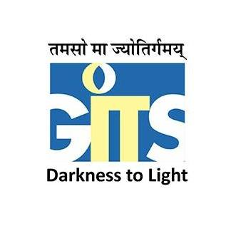

**ACADEMIC YEAR – 2021-22**

**DATABASE MANAGEMENT SYSTEM LAB FILE**

**(4CS4-22)**

# Submitted To : Submitted By:

# Ms. Charu Kavadia & Ms. Ayushi Ghill Gautam Suthar

# Assistant Professor, CSE 21EGICS201

# GITS IV Semester Section A

# VISION & MISSION OF DEPARTMENT

#### **Vision**

#### To nurture the students to become employable graduates who can provide solutions to the societal issues through ICT.

#### **Mission**

#### To focus on practical approach towards learning and exposing the students on the latest ICT technologies.

#### To foster logical thinking among the students to solve real-time problems using innovative approaches.

#### To provide state-of-the-art resources that contributes to inculcate ethical and life-long learning environment.

# COURSE OUTCOMES (COs)

|  |  |
| --- | --- |
| **CO24422.1** | Students will be able to understand various queries execution using DDL, DCL and DML Commands. |
| **CO24422.2** | Students will be able to understand various queries execution using relational constraints and aggregate functions. |
| **CO24422.3** | Students will be able to understand various queries execution using joins and set operations. |
| **CO24422.4** | Students will be able to understand various queries execution using views. |
| **CO24422.5** | Students will be able to understand various queries execution using triggers and cursors and creating the users and assigning their roles. |

**RECOMMENDED SYSTEM/SOFTWARE REQUIREMENTS:**

1. Intel based desktop PC with minimum of 2.6GHZ or faster processor with at least 256 MB RAM and 40GB free disk space.
2. Operating System: Any Windows.
3. Software: Oracle 10g

# TEXT / REFERENCE BOOKS

* H.F. Korth and Silberchatz: Database Concepts, McGraw Hill
* Almasri and S.B. Navathe: Fundamentals of Database Systems
* C.J. Date: Data Base Design, Addison Wesely
* Hansen and Hansen: DBM and Design, PHI

# VIDEO REFERENCE

* https://onlinecourses.nptel.ac.in/noc21_cs04/preview
* https://www.w3schools.com/sql/